Dear Campers and Caregivers,
We are happy to confirm you and your girl’s registration for our She & Me “Teddy Bear Tea Party” Overnight at the Hacienda Program Center. We are extremely excited to embark on this adventure together this summer! Please read the following information carefully, even if you and/or your child has been to camp before. This packet holds important information for a great camp experience.

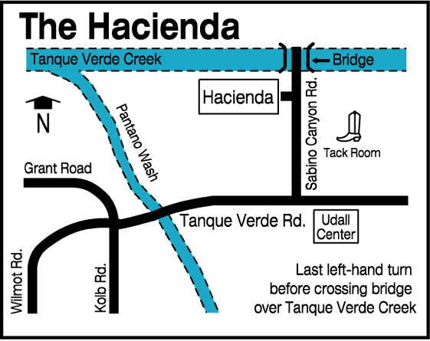
TRANSPORTATION
You are responsible for your own transportation to and from the Hacienda Program Center. The Hacienda is located at 3101 N. Sabino Canyon Road, Tucson, AZ, 85715. A map is provided here for your convenience. Please back-in park in the designated parking areas.

SLEEPING ARRANGEMENTS
Each camper and their adult will be sleeping in an enclosed air-conditioned building with an attached bathroom and kitchenette. Cots and mattresses will be provided and set up prior to camper arrival. Pairs will not have individual rooms – all pairs will be sleeping in two large, shared spaces.

CHECK-IN AND CHECK-OUT SCHEDULE
Thursday, July 9
- 11:00am check-in
Friday, July 10
- 10:00am check-out

Please contact the Camp Director at HaciendaCamp@girlscoutssoaz.org if you plan on arriving after the check-in time or leaving before the check-out time so we can open the security gate accordingly.

FOOD AND BEVERAGES
On the day of arrival, you will be provided lunch, an afternoon snack, dinner, and evening s’mores. The next day you will be provided breakfast and a snack. If someone in your family has special dietary needs, please be sure to note them during registration. If you have concerns regarding our ability to accommodate a dietary restriction, please reach out to us to discuss them further. We will make every effort to accommodate special dietary needs. If you intend to bring special dietary food and beverages, please reach out to us ahead of time so we may ensure we have sufficient space to store them. Please note our property is Nut Free, so please no nuts onsite.

PROGRAM
Participants will receive a schedule of meal and activity times upon arrival. There will be a variety of camp activities offered, including archery or slingshots, swimming, arts and crafts (supplies provided), games, s’more making, etc. Unexpected weather changes may impact program offerings, but backup activities will be provided. You can sign up for various activities at check-in and participate in as many or as few activities as you would like. You MUST stay in your camper-adult pair throughout the entire event for proper supervision of each child. Please note that campers must be 7 years or older to participate in archery; campers under 7 will have the option to participate in a slingshot lesson.

POOL TIME
We swim in the afternoon in our Junior-Olympic-sized pool, weather permitting. Girl Scouts must always remain with their “She” when swimming. Lifeguards will be on duty throughout the duration of pool time. Lifejackets of all sizes will be available for child and adult use. If a lifeguard determines at any point during pool time that a swimmer needs a lifejacket, one MUST be worn. If your camper prefers to use their own lifejacket from home, it may be brought to and used at camp if it is a US Coast Guard approved personal floatation device suitable for your camper’s stature.

You may use a shower to rinse off after swimming, but shower time will be limited to 1 minute per person as shower stalls are very limited. The shower house will be monitored by staff to ensure fair and responsible usage.

REGISTRATION – NOW WITH STEP-BY-STEP VIDEO GUIDE
For camp, we process registration, payment, and health forms all in one place! When you select a camp on our website calendar, you will be brought to a website prompting you to log in. If your child participated in camp last season, you should already have an active account and will be able to access the site.

If it is your first time registering for camp, or you’d like a refresher of our registration process, please follow the instructions provided in this document. We also have a video guide if you prefer to follow along with a visual aide.

CAMP FORMS
Camper health forms are to be completed through the same account and website that was used to register the camper(s) for camp. If there are any missing or incomplete forms or documents on a camper’s profile, we will be unable to welcome them into camp.

When adding individuals to your account, you will be prompted to provide general information for each person. After registering an individual for camp, the main page of your account will show that you have incomplete tasks.
Complete these tasks by filling out the required forms for each individual attending camp – this information is secure and only accessible to camp leadership. When all forms are complete and remaining balances have been paid, your camper will be all set to attend camp. If your camper is attending multiple camps requiring the same forms, you will only need to fill out the form once.

FIRST AID / MEDICATIONS
There will be several first-aiders on site to address medical concerns and injuries. We also have supplies for basic first aid needs. Caregivers (or accompanying adults) are responsible for dispensing all prescribed medications to their own families / youth. We are able to store refrigerated medications if needed. Medications must be in their original prescription container which lists the patient's name, medication, dosage, doctor's name, and phone number.

REFUND POLICY
Please note that your camp balance is due at least 14 days prior to the start of the camp session. Refunds of camp fees (less your deposit) are only available when requested in writing at the council office, at least two weeks before the session begins. Refunds do not include the deposit; deposits are neither refundable nor transferable.

EMERGENCY CONTACT
If an emergency arises and your family needs to get a message to your Girl Scout while they are at camp, you may call (520) 319-3180 or email haciendacamp@girlscoutssoaz.org. We do not allow campers to use the office phone except in emergency situations.

TECHNOLOGY
It is our hope and desire to “disconnect” campers from personal technology and connect them to their community and environment. Please support us in this initiative by avoiding electronic use at camp

TRADING POST
We will have the Trading Post open on Thursday the 9th from noon to 1pm for campers to shop. Items include fun patches, stuffies, pool toys, and more, while supplies last. Girl Scouts may also use Cookie Dough earned from participating in the Product Program (cookie sale). Day Camp staff are not responsible for holding onto money

PACKING LIST (PER PERSON)
- Wear comfortable clothes, socks, closed-toe shoes upon arrival
- 1 packed outfit for Friday (comfortable clothes)
- Backup socks and underwear
- Trading Post money (optional)
- 1 pair poolside/shower shoes (flip-flops are acceptable)
- Pajamas
- Hat
- Sunglasses
- Sunscreen (minimum SPF 30)
- Water bottle labelled with owner’s name – refill stations will be available around the property
- Flashlight or headlamp
- Towel
- Swimsuit
- Sleeping bag
- Pillow
- 1 stuffed animal for our tea party
- Toiletries
  - Hair brush
  - Face wash
  - Toothbrush and toothpaste
  - Menstrual products if needed
  - Deodorant
  - Insect repellent
  - Body lotion
  - Lipbalm
  - Medications, if applicable

Old, comfortable clothes are the best for camp. We recommended not wearing skirts or dresses to camp. Shoes should be sturdy, comfortable and closed toed; no sandals, Crocs or flip flops, except by the pool or while rinsing off at the shower house.

HACIENDA MAP

We hope this information will help you prepare your Girl Scout for an exciting time at Day Camp; we look forward to spending the summer together!

Yours in Girl Scouting,

Sequoia (Pixie) Smith
Day Camp Director
Girl Scouts of Southern Arizona
(520) 319-3180

