**Dear Troop Camp Leaders,**

We are so glad you will be joining us for Troop Camp at Camp Whispering Pines (CWP) on Mount Lemmon. We have an exciting summer ahead, and are excited to have you and your troop joining us!

Please read the following information carefully, even if your child has been to camp before. This packet holds important information for a great camp experience. We’re so glad that you are a part of the CWP family!

**SESSIONS**

Troop Camp 1

* June 30th - July 2nd
* Theme: Zootopia
* Check-in is at 4pm on Friday, and check-out 10am on Sunday.

Troop Camp 2

* July 11th – 13th
* Theme: Dancing Through the Decades Theme
* Check-in is at 4pm on Friday, and check-out 10am on Sunday.

The gate to Camp Whispering Pines will be closed at 9:00pm on the date of your arrival and will not reopen until 7am the following morning. If you plan on arriving after the 4:00pm arrival time for any reason, please contact us to make arrangements.

**FOOD AND BEVERAGES**

Your fees include all meals, beverages and snacks. Please do not allow girls or adults to bring food, candy, gum, or beverages to camp. If someone in your troop has special dietary needs, please be sure to note them during registration. If you have concern regarding our ability to accommodate a dietary restriction, please reach out to us to discuss them further. We will make every effort to accommodate special dietary needs. All food must be stored in the kitchen, and if necessary, we will store special dietary food and beverages for you. If you intend to bring special dietary food and beverages, please reach out to us ahead of time so we may ensure we have sufficient space to store them. We run kitchen reports the week prior to Troop Camp and need to know special dietary needs ahead of time. Please note our property is Nut Free, so please no nuts onsite.

*All of the water used at Camp Whispering Pines is collected from Mother Earth. We ask campers to bring 2 gallons of drinking water up with them if they are able to.

**CHECK IN and PICK UP**

We utilize a drive-through drop off and pick up at all camps. Only the adults and/or leaders that will be staying onsite will be able to park. Leaders and adults staying for the duration of camp will back in to parking spaces in the lot, all other vehicles will drive through. Each troop will have staff partners that will assist campers and leaders through the ins and outs of troop camp. If you arrive before your camper’s leader, the staff partners will provide supervision and support for your Girl Scout until troop leaders arrive. We ask that non-registered caregivers remain in their vehicles throughout the process.

**PROGRAM SELECTION**

Below are brief program descriptions you can share with your girls before camp. We will have sign-up sheets posted outside upon arrival. At that time, your troop will be given options around your schedule. Examples of activities:

* Archery - shoot at a target with a bow and arrow
* Arts & Crafts - make something crafty to take home
* Dancing - learn folk dances and line dances
* Drama - play drama games at the performance center
* Hiking - take a short hike through the forest
* Low Ropes - work together as a team to complete fun challenges
* Music - learn fun, silly camp songs and slow songs, too
* Nature Games - play games that relate to plants and animals and other things in nature
* Outdoor Skills - may practice knots, fire building, trail signs, or dressing for the outdoors
* Rhythm Games - hand clapping, movement, and rhythm chants
* Sports & Games - play teambuilding/group games

**CAMP TRADING POST**   
There will be a Trading Post available at camp. In addition, the Girl Scouts of Southern Arizona shop, located at 4330 E Broadway Blvd, Tucson, AZ 85711, will be stocked with camping items for sale prior to camp. Items for sale in the Trading Post include T-shirts, patches, cups, mugs, hats, jewelry, fuzzy critters and more. Cash, card, and Cookie Dough are accepted in the Trading Post.

**LEADER RESPONSIBILITIES**

We ask the leaders to ensure proper supervision during the entire camp session, including all activities, transition times, and during the night. During selected activities your role will be to support and assist the camp staff leading the activity.  For example, you may need to encourage the campers to stay together as a group, follow our “truddy (3 buddy system)”, help girls remain focused on a topic, etc. You will also be responsible for the campers at all other times, such as wake-up call and walking to the Lodge for meals.

**EVENING ACTIVITIES**

We will have a campfire* on one of your nights at camp and a theme night on the other. The campfire will be complete with songs, skits and s’mores and the more camper involvement, the better. Feel free to start planning your troop’s song or skit for the campfire now! Please check the theme night schedule to see what the theme is for the camp you are attending. The girls can plan to dress up as well if they would like.

*Campfires on Mt. Lemmon are subject to cancellation per Forest Service Restrictions. In the event of fire restrictions, s’mores will still be provided.

**FIRST AID / MEDICATIONS**

Your first aid certified leaders and adults are responsible for dispensing all prescribed medications, and keeping them securely locked during your camp stay. This includes any adult medications. Your first aider is also responsible for the groups first aid kit and rendering aid. Medications must be in their original prescription container which lists the patient's name, medication, dosage, doctor's name, and phone number. Patients must be under current doctor's orders to take prescribed medications.

**MEDICAL HISTORY**    
Physicals are not required for Troop Camp. Please make sure that you have completed your profile on our online registration system for anyone attending Troop camp, including adults. More information about completing your profile is included below. Please make sure each camper, including all adults, have completed the Camper Information, Allergy and Medical History Forms in your registration. We use this to plan meals and other important functions, and ask for these to be completed at least two weeks in advance.

**HEALTH AND WELLNESS**

Our goal is always to provide a safe camp experience for all. We need your help to ensure that our campers and staff stay healthy this summer! We ask all families to do their best to avoid exposure prior to camp.

If any camper or staff tests positive for Covid-19 during camp, we will immediately isolate the camper and contact the caregiver for immediate pick up. That child or staff may not return to camp for five days after the positive test and must be asymptomatic. Unfortunately, we are no longer able to process refunds due to Covid-19 when a camper becomes unwell during a session. For campers who test positive prior to camp, we will do our best to find space in a later session but are unable to provide refunds less than 14 days prior to sessions.

Do not send your camper to camp if they have been exposed to a communicable disease or if they are ill.

If a participant is not immunized, they are required to acknowledge this in their registration profile information.

Please check your camper for lice before coming to camp. You can learn more about lice at headlice.org.

**EMERGENCY CONTACT**   
If a family member needs to get an emergency message to your camper, the phone number at Camp Whispering Pines is (520) 576-1403. This number is strictly for emergencies.

**PACKING FOR CAMP**   
Camp Whispering Pines is located at an elevation of approximately 8,000 feet. Daytime temperatures usually range from the mid-70s to the low-90s. Nights are cool, often in the 40s and 50s. Mt. Lemmon temperatures are typically 20 degrees cooler than the temperatures in Tucson and other low desert areas, but weather patterns are similar. Shorts and t-shirts are appropriate during the day, while sweatshirts and jeans are usually sufficient for outdoor evening activities. A warm sleeping bag is preferred, but if unavailable, you may substitute several warm blankets. Old, comfortable clothes are best for camp. Good sturdy shoes, with tread, are REQUIRED! No sandals, flip flops, crocs, or open toe-shoes are permitted. We recommend that all clothing and belongings be marked with the camper’s name.

**RECOMMENDED CLOTHING / EQUIPMENT LIST**

All Items should be marked with your camper's name! Please feel free to encourage your troop to dress up in a themed costume or troop shirt for theme night!

Clothing

* 3 t-shirts or shirts
* 2 pairs of shorts
* 1 pair of long pants
* 3 pairs of underwear
* 3 pairs of socks (preferably not cotton; synthetic blends work best on active camper feet)
* 1 warm sweater / sweatshirt or light jacket
* 1 pair of pajamas
* Bandana and hat
* 1 pair sturdy closed-toed shoes or hiking boots; athletic shoes with a tread are preferred.

NO sandals, crocs, or open toe-shoes are allowed.

Gear

* Medication lock box
* First Aid Kit
* Rain jacket or poncho
* Water bottle (stainless steel or plastic)
* Flashlight and extra batteries
* Knapsack or small backpack
* Sleeping bag (or blankets)
* Pillow

Toiletry Items

* Toothbrush and toothpaste
* Hairbrush
* Insect repellent (non-aerosol)
* Unscented lotion
* Tissues
* Sunscreen (SPF 30 and higher)
* Lip balm

Optional Items

* Trading Post Money
* Pen / pencil
* Book to read; journal to write in
* Camera and extra batteries
* Dress up outfit or props for theme night
  + TC1 (June 30 – July 2) Zootopia Theme
  + TC2 (July 11 - 13) Dancing Through the Decades Theme
* Sharpie marker (if you plan to get signatures on a t-shirt or hat)

*All of the water used at Camp Whispering Pines is collected from Mother Earth. With limited precipitation this season, water is very precious. We ask campers to bring at least 2 gallons of drinking water up with them if they are able to.

**IMPORTANT**

* PLEASE DO NOT PACK FOOD, CANDY OR GUM OF ANY KIND. Food is an open invitation to animals and insects to join you in your sleeping quarters. For the safety of your camper and fellow campers; candy, food or gum in their personal items and / or in their sleeping bag will be confiscated. There will be plenty of food provided at camp. If your camper has special dietary items, they must be given to their troop leader to give to the camp chef at check-in.
* Please be sure that sleeping bags and backpacks are clean. If these items may have had food spilled on them, they should be washed before camp.
* Body care products should be unscented, including deodorant and lotion. Animals and insects are more attracted to scented products. (Can find at sporting goods stores such as REI, Summit Hut and Sports Authority)
* Leave cell phones, radios, CD/MP3 players, electronic games, blow dryers and similar devices at home. Encourage your camper to enjoy nature and disconnect to reconnect, social media will be there when she gets home. If devices become distracting or problematic for a girl, camp staff will hold the device for safekeeping until checkout. Please help us encourage them to disconnect by modeling it! We do not have available wifi to share with guests, and reception can be very spotty- so feel free to bring your phone for photos, but don’t rely on being able to find signal frequently.
* Please leave sandals at home. Bring only close-toed, sturdy shoes with tread, such as athletic shoes or hiking boots.  Crocs are not considered close toed shoes and are not suitable for traversing camp.
* Please note that open-flame campfires on Mt. Lemmon are subject to cancellation per Forest Service Restrictions.
* Alcohol, drugs, weapons, and smoking are not permitted on property.

**STAFF**  
Our camp staff are thrilled to be back with some returners and some incredible new additions! Our staff are here to help your troop have a smooth camping experience. You can expect for them to share meals with you and show you the ropes. Staff will also lead activities like archery, hikes and arts and crafts. Together with troop volunteers we work to provide campers with fun, safe, and enriching programs. Staff members attend a pre-camp training which includes safety management, child development, CPR and First Aid, and mental health awareness, and your Troop is required to have a certified first aider present onsite.

**REFUND POLICY**

If you have not yet paid your fees in full, please note that the balance due must be paid at least 14 days before the starting date of the session. Also, if you have paid in advance, refunds of camp fees (not including your deposit) are only available when requests are received in writing at the council office at least 14 days before the session begins. Refunds do not include the per person / per session deposit; deposits are not refundable or transferable. Every effort will be made to place your camper in another camp if they cannot attend their scheduled program due to illness (doctor’s note is required) or family emergency.

**CONTACT INFORMATION**

If you have any special needs or questions please contact our Camp Team at [cwpcamp@girlscoutssoaz.org](mailto:cwpcamp@girlscoutssoaz.org). After June 1st you can reach camp staff directly at (520) 576-1403 or connect with us via email.

**DIRECTIONS TO CAMP WHISPERING PINES**Take Catalina Highway up Mount Lemmon. About a half-mile past Milepost 19 turn left on Organization Ridge Road. If you get to Palisades Ranger Station you have gone one block too far. Organization Ridge Road is paved for the first few yards, where the pavement ends bear right onto the dirt road. Whispering Pines is the last camp on the road, about one mile down. Go past the signs that say “Turn around - No Outlet” and you have arrived!  Please follow drive through instructions once at camp.

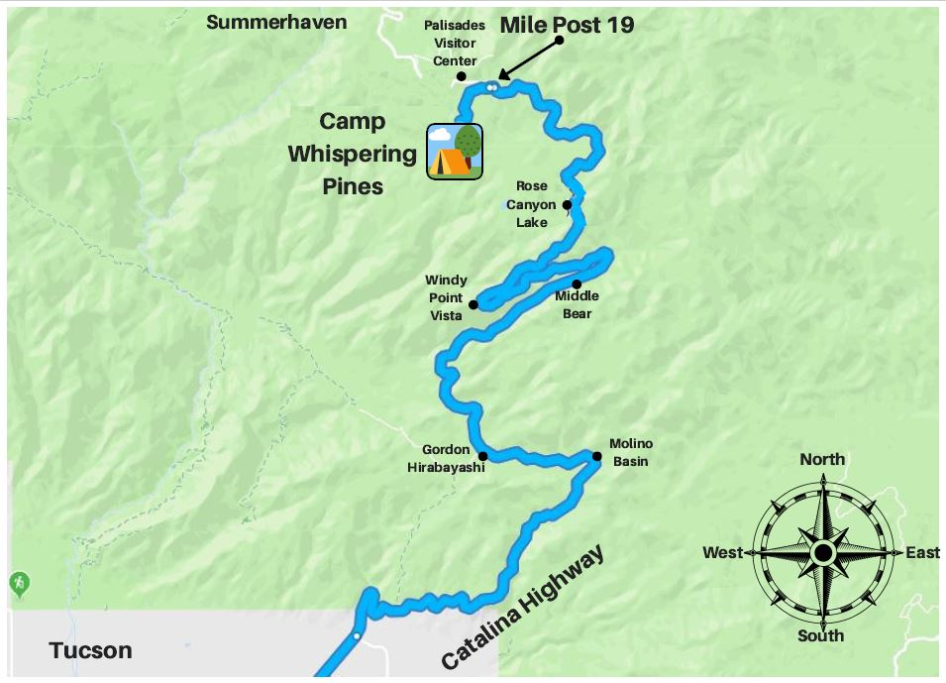

**REGISTRATION**

This year we will be processing registration, payment, and health forms all in one place! You can still visit our Girl Scout website to see the camps available this season. When you select a camp, you will be brought to a website prompting you to log in. If your child participated in camp last season, you should already have an active account and will be able to access the site. You can follow the remaining steps or [refer to this video created by another camp that covers much of the same information.](https://www.youtube.com/watch?v=GWJNDJbsu-o)

If you do not have an account, please create one and add any children in your care (or adults) who will be attending camp as “individuals” to your account. **Please note: you may not add the children of other families in their accounts. Each account may only reflect the household and/or legal guardianship.** We understand this is a new practice for troop leaders who, in the past, have registered multiple Girl Scouts from their troops at one time. This change has been made in effort to ensure caregivers provide the most accurate health information for their campers and directly receive necessary communications from camp staff.

Once logged in, you can select the "Reservations” tab on the main page to explore and register individuals for additional camps. You will only see a list of camps that have remaining spaces and fit the demographics of your household's individuals.

***For those who intend to use troop funds to cover the cost of camp and wish to use these funds for other members of the troop,*** [***please watch this video for a step-by-step walkthrough***](https://youtu.be/rc6nRNaNc4g)***!***

If you intend to pay for camp(s) using your Girl Scout's Cookie Dough or Nutty Dough earned through participating in product program, please contact our Tucson Shop to use your balance to pay for camps.

We hope this information will help you prepare your Girl Scout for an exciting time at Camp Whispering Pines; we look forward to spending the summer together!

Yours in Girl Scouting,

Erin (Acorn) Allen

Alyssa (Peach) Kervran

Camp Whispering Pines Directors

Girl Scouts of Southern Arizona

E Organization Ridge Road

Mount Lemmon, AZ 85619

cwpcamp@girlscoutssoaz.org

(520) 576-1403