**Dear Campers and Parents/Caregivers,**

You made a great choice in registering for Sampler Camp at Camp Whispering Pines (CWP) on Mount Lemmon. We have an exciting summer ahead, and we are so happy you will be joining us!

Please read the following information carefully, even if your child has been to camp before. This packet holds important information for a great camp experience. We’re so glad that you are a part of the CWP family!

**STAFF**  
Our camp staff are thrilled to be back with some returners and some incredible new additions! We work and train as a team to provide campers with fun, safe, and enriching programs. Staff members attend a pre-camp training which includes safety management, child development, CPR and First Aid, and mental health awareness. There is a nurse or EMT on-site at all times and we are within a 911 service area, with an MD on call.

**LIVING ARRANGMENTS**  
Sampler Campers are placed in their own unit. In units, campers live together in a close cluster of cabins or bungalows with staff members sleeping nearby in a central area. Campers are assigned to cabins according to age. We will do our best to accommodate buddy requests for campers who are the same age or extremely close in age range with buddy choices in their registration. Please note that we cannot accommodate buddy requests when there is a significant difference in age.

**CAMP LIFE**   
Camp is a communal living experience. The success of this system depends on the cooperation and involvement of all participants. As part of this process, campers are expected to contribute to the camp by doing kapers (chores). During their stay at camp, campers will participate in traditions and ceremonies and help with the overall cleanliness of their cabins and camp. This will include tidying their belongings, sweeping and picking up trash, and supporting a thriving camp community.

**A TYPICAL DAY**

* 7:00am Wake Up
* 7:45am Flag and Hoppers
* 8:00am Breakfast
* 8:45am Kapers
* 9:00am Camp Programming
* 11:30am Hoppers
* 12:00pm Lunch
* 1:00 - 2:00pm Hour of Tranquility or HOT (rest time)
* 2:00 - 5:45pm Camp Programming
* 5:45pm Flag and Hoppers
* 6:00pm Dinner
* 7:00 - 9:30pm All-Camp Programming
* 9:30 – 10:00pm Scouts Own (wind down in unit time)
* 10:00pm Lights Out

**HEALTH AND WELLNESS**

Our goal is always to provide a safe camp experience for all. We need your help to ensure that our campers and staff stay healthy this summer! We ask all families to do their best to avoid exposure prior to camp.

If any camper or staff tests positive for Covid-19 during camp, we will immediately isolate the camper and contact the caregiver for immediate pick up. That child or staff may not return to camp for five days after the positive test and must be asymptomatic. Unfortunately, we are no longer able to process refunds due to Covid-19 when a camper becomes unwell during a session. For campers who test positive prior to camp, we will do our best to find space in a later session but are unable to provide refunds less than 14 days prior to sessions.

Do not send your camper to camp if they have been exposed to a communicable disease or if they are ill.

If a participant is not immunized, they are required to acknowledge this in their registration profile information.

Please check your camper for lice before coming to camp, as all will be screened upon arrival. Any child with lice will need to spend at least one night in the health center to receive treatment before joining their unit. You will also have the option to take your camper home to treat them there. You can learn more about lice at headlice.org.

**DRIVING TO CAMP**   
Campers should arrive at camp on **Sunday June 8th between 4 and 4:30pm**, as we close our gates at 5pm.  It will be important for families to follow drive-through check-in procedures, as staff will instruct you where to stop and pull forward for drive-through dropoff. Bathrooms for anyone other than campers are not readily available, so please do your best to plan ahead as much as possible. Campers will receive a health check at their vehicle and families will not be permitted inside camper living spaces. We ask that you limit passengers in each car to only members of your household, and we ask that only campers exit the vehicle. Counselors are happy to help campers with their personal items.

**Pickup will be at 10am on Tuesday June 10th**

**HEALTH HISTORY**A documented health examination by a licensed physician, completed in the preceding 12 months, is required prior to your camper’s attendance at camp. We also request recent vaccination records. Please upload a copy of most recent physical to your camper’s registration at least two weeks prior to camp starting. A standard sports, school or camp physical is acceptable.

**IDENTIFICATION CHECK & PICK-UP AUTHORIZATION**For the safety of your camper, we require anyone picking up a camper to present current photo identification upon pick-up. If someone other than the parents / guardians listed on registration will be picking up your camper, you must list them in the pick-up authorization in your camper’s registration and have them be prepared to present a photo I.D. **Pick up for camp is at 10am on Tuesday June 10th at the same location as dropoff.**

**MEDICATIONS**

If prescribed medications are needed, please turn them in to the camp nurse at check-in. **Medications must be in their original prescription container** which lists the patient's name, medication, dosage, doctor's name and phone number. Or, for everyone’s convenience, we prefer printed Pill-Packs that share this information, when possible. We will not dispense prescription medication unless the camper is under current doctor's orders to take the medication. **Please make sure all medications are listed in your Girl Scouts’ health profile. This is really important and will save you so much time at check-in!**

All over-the-counter medications must also be turned over to the nurse at check-in, including vitamins. Our infirmary keeps a sufficient supply of most over-the-counter medications, including pain relievers, cough and sore throat medication, eye drops, etc., and are available for campers as needed, and as indicated via your registration selections. Please do not send over-the-counter medications unless your camper takes one on a routine basis.

If you have any special instructions regarding medications or medical situations for your camper, please submit them in writing both in the registration, and give them to the nurse at check-in time. Please remember to pick up your prescription and non-prescription medications from your campers counselors at pick-up time.

**TRADING POST**

The Trading Post will be open once a week for campers to shop. We highly recommend that campers not keep money with them. Money can be placed in an envelope with their name and the amount of money notated clearly on the front and turned in to staff at check-in. These funds will be available for them when they visit the Trading Post later in the week. Camp Whispering Pines is not responsible for money that is kept with the individual camper and not handed in at check-in. Any remaining Trading Post funds will be sent home with the camper during checkout.

**MAIL**

Mail is a nice addition to every camper’s experience. Your camper will be looking forward to receiving mail from home. We recommend letters from home be cheery and full of inquiries about their camping experience. Upbeat letters from home can be the perfect antidote for homesickness. Please allow enough time for your letters to arrive. You might consider sending a note a few days before your camper leaves for camp. You might also want to hide a letter in their luggage to find while they are unpacking. Letters can also be given to a staff member at check-in to be handed out throughout the duration of their week. Each letter should be labeled with the Girl Scout’s name, Week Theme, and the date it should be delivered to the camper.

Camp Whispering Pines’ mailing address is:

**Your Camper’s Name**

**c/o Camp Whispering Pines**

**(Your Camper’s Program Session Date and main theme—Where Dreams Come True etc.)**

**P.O. Box 760**

**Mt. Lemmon, AZ 85619-0760**

**HOMESICKNESS**

If this is your camper’s first extended camp experience, they may miss home, especially the first day or two. You may receive letters from them indicating they are homesick. They will most likely be over the homesickness by the time the letter reaches you. Homesickness is a normal emotion for new campers, and the staff is trained to handle these situations. To make the transition to camp life go smoothly, we recommend the campers are not told you will come pick them up if they are homesick, or that they will be able to call home. A camper will feel successful and improve their self-esteem by learning to cope with homesickness. We will do our best to make camp a fun and memorable experience for your camper, however, if the homesickness persists, you will be consulted.

**REFUND POLICY**

If you have not yet paid your fees in full, please note that the balance due must be paid at least 14 days before the starting date of the session. Also, if you have paid in advance, refunds of camp fees (minus your deposit) are only available when requests are received in writing at the council office at least 14 days before the session begins. Refunds do not include the per person / per session deposit; deposits are not refundable or transferable. Every effort will be made to place your camper in another camp if they cannot attend their scheduled program due to illness (doctor’s note is required) or family emergency.

**CONTACT INFORMATION**

If you have any special needs or questions, please contact our Camp Team at cwpcamp@girlscoutssoaz.org. After June 1st you can reach camp staff directly at (520) 576-1403 or connect with us via email.

**EMERGENCY CONTACT**

If an emergency arises and your family needs to get a message to your camper while they are at camp, you may call (520) 576-1403. This line is strictly for emergencies and camp business; it may not be used for visiting purposes. We do not allow campers to use the phone except in emergencies.

**THEMES**

Each week at Camp Whispering Pines we have a designated theme night- this year's theme is “Get Your Game On” While packing an outfit for the theme is not necessary, some campers really enjoy dressing up to match the theme.

**PACKING FOR CAMP**CWP is located at an elevation of approximately 8,000 feet. Daytime temperatures usually range from the mid-70s to the low-90s. Nights are cool, often in the 40s and 50s. Mount Lemmon temperatures are typically 20 degrees cooler than the temperatures in Tucson and other low desert areas, but weather patterns are similar. Shorts and t-shirts are appropriate during the day, while sweatshirts and jeans/long warm pants are usually sufficient for outdoor evening activities. A warm sleeping bag is preferred, but if unavailable, you may substitute several warm blankets. Old, comfortable clothes are best for camp. Good sturdy shoes, with tread, are REQUIRED! We recommend that all clothing and belongings be marked with the camper’s name. Due to limited storage space in the bungalows and cabins, each camper may bring ONLY one suitcase or bag, a pillow and one bedroll / sleeping bag, and should be able to carry her items independently.

**RECOMMENDED CLOTHING / EQUIPMENT PACKING LIST**

All items should be marked with your camper's name! Please print a copy of this list to send with your camper to camp. That way they will have it when they are packing at the end of the week.

Clothing

* 3 t-shirts or shirts
* 2 pairs of shorts
* 1 pair of long pants
* 4 pairs of underwear
* 3 Pairs of socks (preferably not cotton; synthetic blends work best on active camper feet)
* 1 warm sweater / sweatshirt or light jacket
* 1 pair of pajamas
* Bandana and hat
* 1-2 pair(s) sturdy closed-toed shoes or hiking boots; athletic shoes with a tread are preferred.

NO sandals, Crocs, or open toe-shoes are allowed around camp

Gear

* Rain jacket or poncho
* Re-usable Water bottle (stainless steel or plastic)
* Flashlight/headlamp and extra batteries
* Knapsack or small backpack
* Sleeping bag (or blankets)
* Pillow

Toiletry Items

* Toothbrush and toothpaste
* Towel and washcloth
* Hairbrush
* Soap, shampoo and conditioner
* Deodorant (unscented)
* Insect repellent (non-aerosol)
* Unscented lotion
* Tissues
* Sunscreen (SPF 30 and higher)
* Lip balm

Optional Items

* Trading Post Money in labeled envelope
* Stationery, pre-addressed envelopes with stamps
* Pen / pencil
* Book to read; journal to write in
* Camera and extra batteries
* Outfit for the theme night (See weekly Themes)
* *All of the water used at Camp Whispering Pines is collected from Mother Earth. With limited precipitation, water is very precious. We ask campers to bring at least 2 gallons of drinking water up with them if they are able to.

**IMPORTANT**

* PLEASE DO NOT PACK FOOD, CANDY OR GUM OF ANY KIND. Food is an open invitation to all animals and insects to join you in your sleeping quarters. For the safety of your camper and their bungalow mates; candy, food or gum in their personal items and / or in their sleeping bag will be confiscated. There will be plenty of food provided at camp. If your camper has special dietary items, they must be given to the camp chef at check-in. Please contact staff prior to check-in to see how our kitchen staff can accommodate your camper’s dietary needs or to make arrangements for storage of special dietary items.
* Please be sure that sleeping bags and backpacks are clean. If these items may have had food spilled on them, they should be washed before camp.
* Body care products should be unscented, including soap, deodorant, lotion, etc. Animals and insects are more attracted to scented products. (Can find at sporting goods stores such as REI, Summit Hut and Sports Authority.)
* Leave cell phones, radios, CD / MP3 players, electronic games, makeup, blow dryers and similar devices at home. Encourage your camper to enjoy nature and explore their sense of adventure, social media will be there when they get home. Cell phones and other connected devices will be confiscated and held until checkout.
* Bring only close-toed, sturdy shoes with tread, such as athletic shoes or hiking boots. Crocs are not considered close toed and are not suitable for traversing camp.
* Remember, all prescription and non-prescription medications and vitamins are to be given to camp staff at check-in. Be sure medications are in their original containers, or in commercial Pill Packs marked with your camper’s name.
* Please note that open-flame campfires on Mt. Lemmon are subject to cancellation per Forest Service Restrictions.

**DIRECTIONS TO CAMP WHISPERING PINES**Take Catalina Highway up Mount Lemmon. About a half-mile past Milepost 19 turn left on Organization Ridge Road. If you get to Palisades Ranger Station you have gone one block too far. Organization Ridge Road is paved for the first few yards, where the pavement ends bear right onto the dirt road. Whispering Pines is the last camp on the road, about one mile down. Go past the signs that say “Turn around - No Outlet” and you have arrived!  Please follow drive through instructions once at camp.

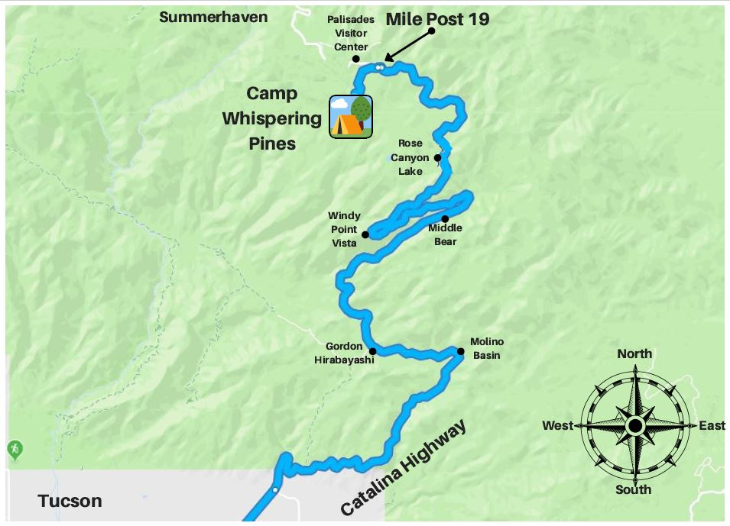

**REGISTRATION**

This year we will be processing registration, payment, and health forms all in one place! You can still visit our Girl Scout website to see the camps available this season. When you select a camp, you will be brought to a website prompting you to log in. If your child participated in camp last season, you should already have an active account and will be able to access the site. You can follow the remaining steps or [refer to this video created by another camp that covers much of the same information.](https://www.youtube.com/watch?v=GWJNDJbsu-o)

If you do not have an account, please create one and add any children in your care (or adults) who will be attending camp as “individuals” to your account. **Please note: you may not add the children of other families in their accounts. Each account may only reflect the household and/or legal guardianship.** We understand this is a new practice for troop leaders who, in the past, have registered multiple Girl Scouts from their troops at one time. This change has been made in effort to ensure caregivers provide the most accurate health information for their campers and directly receive necessary communications from camp staff.

Once logged in, you can select the "Reservations” tab on the main page to explore and register individuals for additional camps. You will only see a list of camps that have remaining spaces and fit the demographics of your household's individuals.

***For those who intend to use troop funds to cover the cost of camp and wish to use these funds for other members of the troop,*** [***please watch this video for a step-by-step walkthrough***](https://youtu.be/rc6nRNaNc4g)***!***

If you intend to pay for camp(s) using your Girl Scout's Cookie Dough or Nutty Dough earned through participating in product program, please contact our Tucson Shop to use your balance to pay for camps.

**CAMP FORMS**

Camper health forms are to be completed through the same account and website that was used to register the camper(s) for camp. If there are any missing or incomplete forms or documents on a camper’s profile, we will be unable to welcome them into camp.

When adding individuals to your account, you will be prompted to provide general information for each person. After registering an individual for camp, the main page of your account will show that you have incomplete tasks.

Complete these tasks by filling out the required forms for each individual attending camp – this information is secure and only accessible to camp leadership. When all forms are complete and remaining balances have been paid, your camper will be all set to attend camp. If your camper is attending multiple camps requiring the same forms, you will not need to fill them out multiple times.

The information you provide by filling out the profile(s) and forms in their entirety gives us the tools to be able to respond to your child’s individual needs. Some caregivers hesitate to provide us with personal information about their camper's behavior. They may be concerned that the information will be misused or cause a camper to be singled out or treated differently. We understand these concerns, but please know how invaluable such information can be in assisting us to help your camper make a smooth and happy adjustment to camp. Having prior knowledge about a sleeping disorder, learning difficulty, ADHD, recent loss, or major life change makes a tremendous difference in enabling us to be sensitive to your camper’s need for extra patience, understanding, or reassurance, especially in the first days of camp. Information is reviewed by only those staff members who will work directly with your camper. Otherwise, all information is kept strictly confidential.

ONLY the following camps require a physical to be uploaded:

* Camp Fury
* CWP: Where Dreams Come True
* CWP: CIT
* CWP: Get Your Game On
* CWP: Camp Sampler
* Operation Purple Shirt
* CWP: CIT II
* CWP: Campers Got Talent
* Day Camp Overnight: Party in the USA
* CWP: Shark Week

The information you provide by filling out the profile(s) and forms in their entirety gives us the tools to be able to respond to your child’s individual needs. Some caregivers hesitate to provide us with personal information about their camper's behavior. They may be concerned that the information will be misused or cause a camper to be singled out or treated differently. We understand these concerns, but please know how invaluable such information can be in assisting us to help your camper make a smooth and happy adjustment to camp. Having prior knowledge about a sleeping disorder, learning difficulty, ADHD, recent loss, or major life change makes a tremendous difference in enabling us to be sensitive to your camper’s need for extra patience, understanding, or reassurance, especially in the first days of camp. Information is reviewed by only those staff members who will work directly with your camper. Otherwise, all information is kept strictly confidential.

We hope this information will help you prepare your Girl Scout for an exciting time at Camp Whispering Pines; we look forward to spending the summer together!

Yours in Girl Scouting,

Erin (Acorn) Allen

Alyssa (Peach) Kervran

Camp Whispering Pines Directors

Girl Scouts of Southern Arizona

E Organization Ridge Road

Mount Lemmon, AZ 85619

[cwpcamp@girlscoutssoaz.org](mailto:cwpcamp@girlscoutssoaz.org)

(520) 576-1403