**Dear Friends & Family Campers,**

We are so glad you will be joining us for Friends & Family Camp at Camp Whispering Pines (CWP) on Mount Lemmon. We have an exciting summer ahead and are excited to have you and your group joining us! **Please read the following information carefully, even if your group has been to camp before.** This packet holds important information for a great camp experience. We’re so glad that you are a part of the CWP family! Our goal is to provide you and your family with a unique opportunity to have fun together safely this summer. Our camp staff will offer a variety of camp activities; you can participate in these activities or just relax together in the cool pines.

When you arrive at Camp Whispering Pines, please back into a parking space.

**BUNGALOW & CABIN ASSIGNMENTS**   
Bungalows and cabins are assigned by request upon registration but may be subject to change due to accessibility needs. If you have concerns or need accommodations, please let us know at least two weeks in advance in your registration forms.

**MEDICAL INFO**   
Please make sure each camper, including all adults, have completed the Camper Information, Allergy and Medical History Forms in your registration. We use this to plan meals and other important functions, and ask for these to be completed at least two weeks in advance.

Physicals are not required for Friends & Family Camp. Please make sure that you have completed your profile on our online registration system for anyone attending Friends & Family Camp, including adults. More information about completing your profile is included below.

**SESSIONS**

* Friday July 4th, 4:00pm arrival- Sunday July 6th, 10:00am checkout
  + Theme: Party in the USA
* Tuesday July 8th, 4:00pm arrival- Thursday July 10th, 10:00am checkout
  + Theme: Giddy Up Galaxy

The gate to Camp Whispering Pines will be closed at 9:00pm on the date of your arrival and will not reopen until 7:00am the following morning. If you plan on arriving after the 4:00pm arrival time for any reason, please contact us to make arrangements.

**PROGRAM**   
There will be a variety of camp activities offered, including archery, hiking, arts and crafts (supplies provided), drama games, dancing, and/or yoga. You can sign up at check-in and participate in as many or as few activities as you would like. Please make sure that any youth participants are always accompanied by an adult at all activities and during transition times. Please note that campers must be 7 years or older to participate in archery. Campers under 7 will have the option to participate in a slingshot lesson.

**EVENING ACTIVITIES**

We will have a campfire* on one of your nights at camp and a theme night on the other. The campfire will be complete with songs, skits and s’mores and the more camper involvement, the better. Feel free to start planning a skit or song for the campfire now!

*Campfires on Mt. Lemmon are subject to cancellation per Forest Service Restrictions. In the event of fire restrictions, s’mores will still be provided.

**CAMP TRADING POST**    
There will be a Trading Post available at camp during your stay. In addition, the Girl Scouts of Southern Arizona shop, located at 4330 E Broadway Blvd, Tucson, AZ 85711, will be stocked with camping items for sale prior to camp. Items for sale in the Trading Post include T-shirts, patches, cups, mugs, hats, jewelry, fuzzy critters and more. Cash, card, and Cookie Dough are accepted as forms of payment. The camp Trading Post accepts cash, card, and Cookie Dough as valid forms of payment.

**FOOD AND BEVERAGES**

Your fees include all meals, beverages and snacks. Please do not allow girls or adults to bring any food, candy, gum, or beverages to camp. If someone in your family has special dietary needs, please be sure to note them during registration. If you have concern regarding our ability to accommodate a dietary restriction, please reach out to us to discuss them further. We will make every effort to accommodate special dietary needs. All food must be stored in the kitchen, and if necessary, we will store special dietary food and beverages for you. If you intend to bring special dietary food and beverages, please reach out to us ahead of time so we may ensure we have sufficient space to store them. We run kitchen reports the week prior to Friends & Family Camp and need to know special dietary needs ahead of time. Please note our property is Nut Free, so please no nuts onsite.

*All of the water used at Camp Whispering Pines is collected from Mother Earth. We ask campers to bring 2 gallons of drinking water up with them if they are able to.

**FIRST AID / MEDICATIONS**   
There will be several first-aiders on site to address medical concerns and injuries. We also have supplies for basic first aid needs. Caregivers (or accompanying adults) are responsible for dispensing all prescribed medications to their own families / youth. We are able to store refrigerated medications if needed. Medications must be in their original prescription container which lists the patient's name, medication, dosage, doctor's name, and phone number.

**REFUND POLICY**   
If you have not yet paid your fees in full, please note that the balance due must be paid 14 days prior to the start of the session. Refunds do not include per person / per session deposit; deposits are not refundable or transferable.

**PACKING FOR CAMP**

It can be quite chilly in the mountains, so be sure to pack a warm sweater, jacket, long pants, and plenty of socks. A warm sleeping bag is preferred, but if unavailable, you may substitute several warm blankets. Old, comfortable clothes are best for camp. Good sturdy shoes are essential – no crocs or open-toed shoes! We recommend that all clothing and belongings be marked with the owner’s name.

**RECOMMENDED CLOTHING / EQUIPMENT**

PLEASE NOTE: We do NOT provide sleeping bags & pillows at camp, you must pack these items!  Showers are NOT available for our shorter camp sessions.

Clothing

* 2 t-shirts or shirts
* 1 pairs of shorts
* 1 pair of jeans
* 2 pairs of underwear
* 2 pairs of socks
* 1 warm sweater / sweatshirt or light jacket
* 1 pair of pajamas
* Bandana or hat
* 1 pair sturdy closed-toe shoes or hiking boots with a tread; athletic shoes are preferred. Crocs are not considered close-toed shoes or suitable for traversing camp.

Gear

* Rain jacket or poncho
* Water bottle
* Flashlight and extra batteries
* Knapsack or small backpack
* Sleeping bag & pillow

Toiletry Items

* Toothbrush and toothpaste
* Brush / comb
* Soap
* Deodorant
* Insect repellent (no aerosol!)
* Sunscreen (SPF 30 and higher)
* Lip balm
* Medications

Optional Items

* Book and Journal
* Camera and extra batteries
* Theme night outfit

*All water used at Camp Whispering Pines is collected from Mother Earth. With limited precipitation this season, water is very precious.  We ask campers to bring 2 gallons of drinking water up with them if they are able to.

**TECHNOLOGY**

It is our hope and desire to “disconnect” campers from personal technology and connect them to their community and environment. Please support us in this initiative by avoiding electronic use at camp. Cell phone service is limited on camp property, but our CWP office number can be used for emergency purposes.

**CONTACT INFORMATION AND PHONE NUMBER**   
If you have any special needs or questions please contact our Camp team at [cwpcamp@girlscoutssoaz.org](mailto:cwpcamp@girlscoutssoaz.org), or our CWP office number at (520) 576-1403 after June 1st. Our CWP office number is the also the number where someone can reach you or leave a message while you are at camp. This line is only for emergencies and camp business; it is not to be used for visiting purposes.

**DIRECTIONS TO CAMP WHISPERING PINES**Take Catalina Highway up Mount Lemmon. About a half-mile past Milepost 19 turn left on Organization Ridge Road. If you get to Palisades Ranger Station you have gone one block too far. Organization Ridge Road is paved for the first few yards, where the pavement ends bear right onto the dirt road. Whispering Pines is the last camp on the road, about one mile down. Go past the signs that say “Turn around - No Outlet” and you have arrived!  Please follow drive through instructions once at camp.

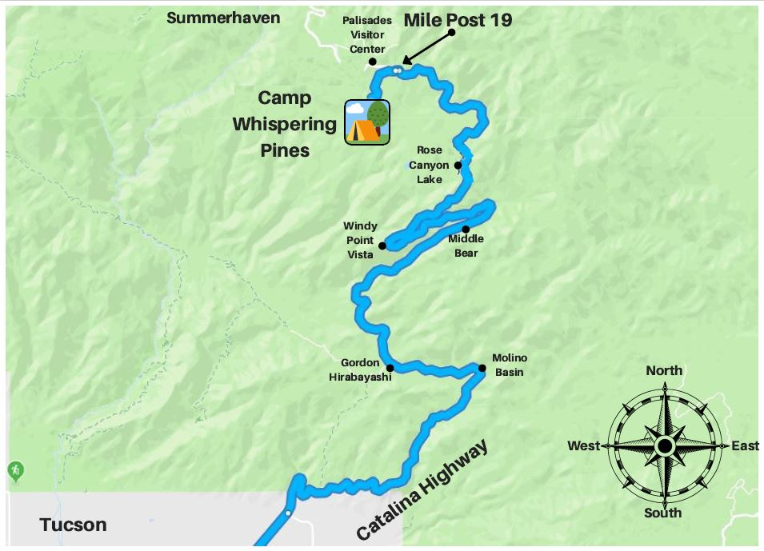

**REGISTRATION**



This year we will be processing registration, payment, and health forms all in one place! You can still visit our Girl Scout website to see the camps available this season. When you select a camp, you will be brought to a website prompting you to log in. If you and/or your child participated in camp last season, you should already have an active account and will be able to access the site. You can follow the remaining steps or [refer to this video created by another camp that covers much of the same information.](https://www.youtube.com/watch?v=GWJNDJbsu-o)

If you do not have an account, please create one and add any children in your care (or adults) who will be attending camp as “individuals” to your account. **Please note: you may not add the children of other families in their accounts. Each account may only reflect the household and/or legal guardianship.**

Once logged in, you can select the "Reservations” tab on the main page to explore and register individuals for additional camps. You will only see a list of camps that have remaining spaces and fit the demographics of your household's individuals.

If you intend to pay for camp(s) using your Girl Scout's Cookie Dough or Nutty Dough earned through participating in product program, please contact our Tucson Shop to use your balance to pay for camps.

We hope this information will help you prepare your Girl Scout for an exciting time at Camp Whispering Pines; we look forward to spending the summer together!

Yours in Girl Scouting,

Erin (Acorn) Allen

Alyssa (Peach) Kervran

Camp Whispering Pines Directors

Girl Scouts of Southern Arizona

E Organization Ridge Road

Mount Lemmon, AZ 85619

[cwpcamp@girlscoutssoaz.org](mailto:cwpcamp@girlscoutssoaz.org)

(520) 576-1403 (After June 1st)