**Dear Camper and Parents/Caregivers,**

We are happy to confirm your Girl Scout’s registration for our Day Camp ‘Party In The USA’ Overnight at the Hacienda Program Center. We are extremely excited to embark on this adventure together this summer; it will be a blast!

Please read the following information carefully, even if your child has been to camp before. This packet holds important information for a great camp experience.

Each of our day camps offers a group of distinct activities that will challenge every Girl Scout to bring out their inner creativity and personality. Camp is a place for Girl Scouts of all ages to let loose and be themselves. You will be impressed with how your child will improve their self-esteem and develop leadership skills all while having the experience of a lifetime. Campers will take part in archery, swimming, and other traditional camp activities - and of course, make new friends!

**STAFF**

Our camp staff are thrilled to be back with some returners and some incredible new additions! We work and train as a team to provide campers with fun, safe, and enriching programs. Staff members attend a pre-camp training which includes safety management, child development, CPR and First Aid, and mental health awareness, diversity equity and inclusion training, group management and program leadership. Our staff is dynamic, energetic, and eager to provide your Girl Scout with a summer full of adventure.

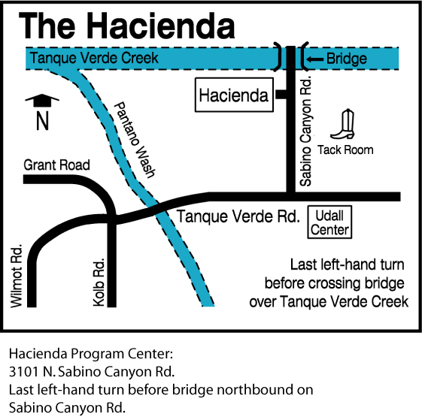

**TRANSPORTATION**

You are responsible for your camper’s transportation to and from the Hacienda Program Center each day. The Hacienda is located at **3101 N. Sabino Canyon Road, Tucson, AZ, 85715**. A map is provided here for your convenience.

**HEALTH AND WELLNESS**

Our goal is always to provide a safe camp experience for all. We need your help to ensure that our campers and staff stay healthy this summer! We ask all families to do their best to avoid exposure prior to camp.

If any camper or staff tests positive for Covid-19 during camp, we will immediately isolate the camper and contact the caregiver for immediate pick up. That child or staff may not return to camp for five days after the positive test and must be asymptomatic. Unfortunately, we are no longer able to process refunds due to Covid-19 when a camper becomes unwell during a session. For campers who test positive prior to camp, we will do our best to find space in a later session but are unable to provide refunds less than 14 days prior to sessions.

**CHECK-IN AND CHECK-OUT SCHEDULE**

Monday, June 30

* 8:00am Drop-Off

Wednesday, July 2nd

* 4:30pm Pick-Up

**CHECK-IN**

**Check in runs from 8am-8:30am**. This drop-off loop is located south of the Grand Ramada (building 3 on the map provided later in this packet). Our staff will assist with grabbing their luggage. Adults will be asked to stay in their vehicles during check-in and check-out. If you have any special concerns about your camper that you would like the staff to be aware of, please plan to arrive at 8am on Monday to discuss them. Girl Scouts must be dropped off by 8:30 am.

**CHECK-OUT**

A photo ID is required at our drive through check-out each day in order to ensure that staff are sending campers home with the appropriate adult. Any adults who have been authorized to pick up your child must be listed on your camper’s profile to be able to pick up your camper. Check-out starts at 4:30 pm. Campers must be picked up no later than **5:00 pm**.

**FOOD**

Please pack 1 sack lunch for Monday and a labeled reusable water bottle for your camper. Girl Scouts will be very active, so please pack a hearty and healthy lunch. **Due to allergies, we are a nut-free zone; no nuts of any variety are permitted within the facility.** Any food containing nuts that is brought to camp will be confiscated.If your camper has any food allergies, please identify them as soon as possible on their online profile, where registration was processed.

Food will be provided for Monday dinner, Tuesday breakfast, Tuesday lunch, Tuesday Dinner, Wednesday breakfast and Wednesday lunch. We also provide snacks daily between meals. We will be taking dietary restrictions into consideration for each meal, so please ensure your camper’s profile notes any dietary needs or restrictions. If your Girl Scout is a picky eater, you may want to bring extra food and snacks for them to eat during their time at camp. We will have refrigerators and microwaves available for these additional foods. **Please ensure that any food brought do not contain any nuts or nut products!**

**DAILY ACTIVITIES**

* Morning Flag Ceremony and announcements
* First activities – for some, this will be archery or slingshots
* 12:00pm Lunch
* HOT (Hour of Tranquility, rest time)
* Swim time
* Quick (2 minutes per person) rinse-off in our pool showers
* Second activities (tie dye, slime, crafts, etc.)
* Dinner
* Kapers (cleanup) and Reflection
* Bed time wind-down and lights out

**UNITS**

Campers will be divided into units or groups based on their ages. Since this overnight experience has a smaller capacity than our usual day camps, we will likely split campers into two units according to age, but will spend the majority of the day in one large group.

**REGISTRATION**

This year we will be processing registration, payment, and health forms all in one place! You can still visit our Girl Scout website to see the camps available this season. When you select a camp, you will be brought to a website prompting you to log in. If your child participated in camp last season, you should already have an active account and will be able to access the site. You can follow the remaining steps or [refer to this video created by another camp that covers much of the same information.](https://www.youtube.com/watch?v=GWJNDJbsu-o)

If you do not have an account, please create one and add any children in your care (or adults) who will be attending camp as “individuals” to your account. **Please note: you may not add the children of other families in their accounts. Each account may only reflect the household and/or legal guardianship.** We understand this is a new practice for troop leaders who, in the past, have registered multiple Girl Scouts from their troops at one time. This change has been made in effort to ensure caregivers provide the most accurate health information for their campers and directly receive necessary communications from camp staff.

Once logged in, you can select the "Reservations” tab on the main page to explore and register individuals for additional camps. You will only see a list of camps that have remaining spaces and fit the demographics of your household's individuals.

***For those who intend to use troop funds to cover the cost of camp and wish to use these funds for other members of the troop,*** [***please watch this video for a step-by-step walkthrough***](https://youtu.be/rc6nRNaNc4g)***!***

If you intend to pay for camp(s) using your Girl Scout's Cookie Dough or Nutty Dough earned through participating in product program, please contact our Tucson Shop to use your balance to pay for camps.

**CAMP FORMS**

Camper health forms are to be completed through the same account and website that was used to register the camper(s) for camp. If there are any missing or incomplete forms or documents on a camper’s profile, we will be unable to welcome them into camp.

When adding individuals to your account, you will be prompted to provide general information for each person. After registering an individual for camp, the main page of your account will show that you have incomplete tasks.



Complete these tasks by filling out the required forms for each individual attending camp – this information is secure and only accessible to camp leadership. When all forms are complete and remaining balances have been paid, your camper will be all set to attend camp. If your camper is attending multiple camps requiring the same forms, you will not need to fill them out multiple times.

The information you provide by filling out the profile(s) and forms in their entirety gives us the tools to be able to respond to your child’s individual needs. Some caregivers hesitate to provide us with personal information about their camper's behavior. They may be concerned that the information will be misused or cause a camper to be singled out or treated differently. We understand these concerns, but please know how invaluable such information can be in assisting us to help your camper make a smooth and happy adjustment to camp. Having prior knowledge about a sleeping disorder, learning difficulty, ADHD, recent loss, or major life change makes a tremendous difference in enabling us to be sensitive to your camper’s need for extra patience, understanding, or reassurance, especially in the first days of camp. Information is reviewed by only those staff members who will work directly with your camper. Otherwise, all information is kept strictly confidential.

**MEDICATIONS**

If prescribed medications are needed, please turn them into the camp staff at check-In. Medications must be in their original prescription container which lists patient's name, medication, dosage, doctor's name and phone number. We will not dispense prescription medication unless the camper is under current doctor's orders to take the medication. **Please ensure all medications are listed on the camper’s UltraCamp profile**.

All over-the-counter medications must also be turned over to the staff at check-in, including vitamins. The camp office keeps a sufficient supply of most over-the-counter medications. Pain relievers, cough and sore throat medication, and eye drops are all part of our inventory and are available, as needed. Please do not send over-the-counter medications unless your camper takes them on a routine basis.

We recommend beginning a subscription to PillPack or a similar service through your camper’s pharmacy. These services consolidate all daily medications into one package that indicates the camper’s name, the included medications and their quantities, as well as when they are to be taken. In place of prescription containers, PillPacks can be brought in by caregivers and administered by camp staff to their campers.

If you have any special instructions regarding medications or medical situations for your camper, please let a staff member know at check-in time. Please remember to pick up your Girl Scout’s prescription and non-prescription medications at check-out on Friday.

**REFUND POLICY**

Please note that your camp balance is due at least 14 days prior to the start of the camp session. Refunds of camp fees (less your deposit) are only available when requested in writing at the council office, at least two weeks before the session begins. Refunds do not include the deposit; deposits are neither refundable nor transferable. Every effort will be made to place your Girl Scout in another camp if they cannot attend their scheduled program due to illness (doctor’s statement required) or family emergency.

**EMERGENCY CONTACT**

If an emergency arises and your family needs to get a message to your Girl Scout while they are at camp, you may call (520) 319-3180 or email haciendacamp@girlscoutssoaz.org. We do not allow campers to use the office phone except in emergency situations.

**TECHNOLOGY**

Cell phones, iPods, handheld electronic games, laptops, etc. are not permitted at camp. It is our hope and desire to “disconnect” campers from personal technology and connect them to their community and environment. If these devices are seen by any staff member, they will be taken and held safely in Casa Catalina for the duration of the day and returned to the camper at check-out.

**PACKING LIST**

* Wear comfortable clothes, socks, closed-toe shoes upon arrival
* 1 outfit for Tuesday (comfortable clothes)
* 1 outfit for Wednesday (comfortable clothes)
* 2 pairs of underwear
* 2 pairs of socks
* 1 extra pair of sturdy closed-toe shoes
* 1 pair poolside/shower shoes (flip-flops)
* Pajamas
* Hat
* Sunglasses
* 1 Sack lunch for Monday (NO NUTS)
* Sunscreen (minimum SPF 30)
* Water bottle
* Towel
* Swimsuit
* Sleeping bag
* Pillow
* Toiletries
  + Hair brush
  + Face wash
  + Toothbrush and toothpaste
  + Menstrual products if needed
  + Deodorant
  + Insect repellent
  + Body lotion
  + Tissues
  + Lipbalm

Old, comfortable clothes are the best for camp. We recommended that Girl Scouts do not wear skirts or dresses to camp. Shoes should be sturdy, comfortable and closed toed; **no sandals, Crocs or flip flops, except by the pool or while rinsing off at the shower house.** We recommend that all clothing and belongings be **marked with your camper’s name**.

**DAILY CAMP THEMES**

Please find the schedule for the camp spirit days below. We encourage all staff and campers to participate.

* Monday | Girl Scout Pride Day – wear your favorite Girl Scout shirt or anything green!
* Tuesday | Theme Day – wear an outfit or accessories that match that week’s camp theme (Party in the USA)!
* Wednesday | Wacky Sock Wednesday

**POOL TIME**

We swim **every day**. Please pack your camper a swimsuit, towel, and sunscreen. Each Monday, a swim test will be conducted. Campers who elect to not take the swim test or do not pass the swim test will wear lifejackets for the duration of the week while swimming. If you own a US Coast Guard approved personal floatation device that your Girl Scout prefers, please send this with them each day.

**MOVIE SHOWING**

During this overnight experience, campers will gather to view a movie that matches the theme for that week of camp. Movies will be rated either G or PG and will have been pre-screened by camp staff to ensure the content is appropriate. Most movies shown are produced by Disney, Pixar, Dreamworks, Illumination, etc.

**HACIENDA MAP**

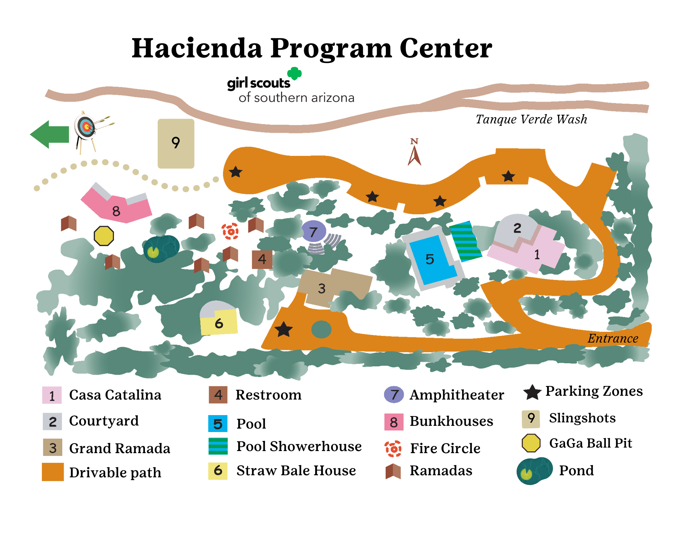

We hope this information will help you prepare your Girl Scout for an exciting time at Day Camp; we look forward to spending the summer together!

Yours in Girl Scouting,

Sequoia (Pixie) Smith

Cass (Sparky) Johnson

Day Camp Co-Directors

Girl Scouts of Southern Arizona

4300 E Broadway Blvd

Tucson, AZ 85711

(520) 319-3180