**Dear Camper and Parents/Caregivers,**

We are happy to confirm your Girl Scout’s registration for Day Camp at the Hacienda Program Center. We are extremely excited to embark on this adventure together this summer- it will be a blast!

Please read the following information carefully, even if your child has been to camp before. This packet holds important information for a great camp experience.

Each of our day camps offers a group of distinct activities that will challenge every Girl Scout to bring out their inner creativity and personality. Camp is a place for Girl Scouts of all ages to let loose and be themselves. You will be impressed with how your child will improve their self-esteem and develop leadership skills all while having the experience of a lifetime. Campers will take part in archery, swimming, and other traditional camp activities - and of course, make new friends!

**STAFF**

Our camp staff are thrilled to be back with some returners and some incredible new additions! We work and train as a team to provide campers with fun, safe, and enriching programs. Staff members attend a pre-camp training which includes safety management, child development, CPR and First Aid, and mental health awareness, diversity equity and inclusion training, group management and program leadership. Our staff is dynamic, energetic, and eager to provide your Girl Scout with a summer full of adventure.

**TRANSPORTATION**

You are responsible for your camper’s transportation to and from the Hacienda Program Center each day. The Hacienda is located at **3101 N. Sabino Canyon Road, Tucson, AZ, 85715**. A map is provided here for your convenience. 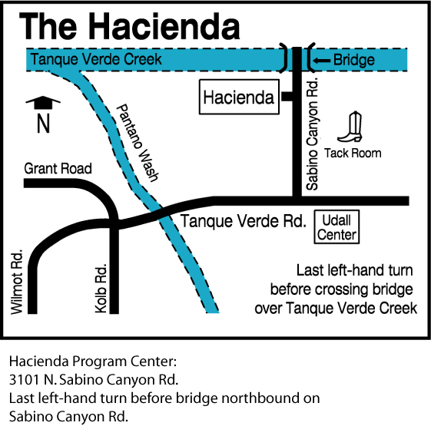

**HEALTH AND WELLNESS**

Our goal is always to provide a safe camp experience for all. We need your help to ensure that ourscampers and staff stay healthy this summer! We ask all families to do their best to avoid exposure prior to camp.

If any camper or staff tests positive for Covid-19 during camp, we will immediately isolate the camper and contact the caregiver for immediate pick up. That child or staff may not return to camp for five days after the positive test and must be asymptomatic. Unfortunately, we are no longer able to process refunds due to Covid-19 when a camper becomes unwell during a session. For campers who test positive prior to camp, we will do our best to find space in a later session but are unable to provide refunds less than 14 days prior to sessions.

We ask that you help us by not sending your camper to camp if they are feeling unwell.

**A TYPICAL DAY AT CAMP**

* 8:00am Drop-Off
* 8:30am Flag Ceremony and morning announcements
* 9:00am First activities – for some, this will be archery or slingshots
* 10:15am Snack
* 10:30am Second activities
* 12:00pm Lunch
* 12:30pm HOT (Hour of Tranquility, rest time)
* 1:00pm – 2:45pm Swim time, including changing times
* 2:45pm Snack
* 3:00pm Third Activities
* 4:00pm Kapers (cleanup) and Reflection
* 4:30pm Pick-Up

**UNITS**

Campers will be divided into units or groups based on their ages. Our youngest Girl Scouts will be in the Ringtails unit, our middle-aged Girl Scouts will be in the Jackrabbits unit, and our oldest Girl Scouts will be in the Bobcats unit. Due to varying age ranges, returning campers may be in different units during different weeks of camp, though their overall camp experience should not be impacted. Program Aides will be in their own “roaming” unit, meeting in the morning together and spending the rest of the day split amongst the other units.

**REGISTRATION**

This year we will be processing registration, payment, and health forms all in one place! You can still visit our Girl Scout website to see the camps available this season. When you select a camp, you will be brought to a website prompting you to log in. If your child participated in camp last season, you should already have an active account and will be able to access the site. You can follow the remaining steps or [refer to this video created by another camp that covers much of the same information.](https://www.youtube.com/watch?v=GWJNDJbsu-o)

If you do not have an account, please create one and add any children in your care (or adults) who will be attending camp as “individuals” to your account. **Please note: you may not add the children of other families in their accounts. Each account may only reflect the household and/or legal guardianship.** We understand this is a new practice for troop leaders who, in the past, have registered multiple Girl Scouts from their troops at one time. This change has been made in effort to ensure caregivers provide the most accurate health information for their campers and directly receive necessary communications from camp staff.

Once logged in, you can select the "Reservations” tab on the main page to explore and register individuals for additional camps. You will only see a list of camps that have remaining spaces and fit the demographics of your household's individuals.

***For those who intend to use troop funds to cover the cost of camp and wish to use these funds for other members of the troop,*** [***please watch this video for a step-by-step walkthrough***](https://youtu.be/rc6nRNaNc4g)***!***

If you intend to pay for camp(s) using your Girl Scout's Cookie Dough or Nutty Dough earned through participating in product program, please contact our Tucson Shop to use your balance to pay for camps.

**CAMP FORMS**

Camper health forms are to be completed through the same account and website that was used to register the camper(s) for camp. If there are any missing or incomplete forms or documents on a camper’s profile, we will be unable to welcome them into camp.

When adding individuals to your account, you will be prompted to provide general information for each person. After registering an individual for camp, the main page of your account will show that you have incomplete tasks.

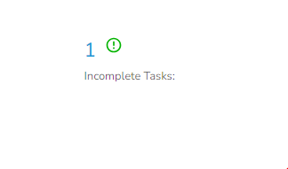

Complete these tasks by filling out the required forms for each individual attending camp – this information is secure and only accessible to camp leadership. When all forms are complete and remaining balances have been paid, your camper will be all set to attend camp. If your camper is attending multiple camps requiring the same forms, you will not need to fill them out multiple times.

The information you provide by filling out the profile(s) and forms in their entirety gives us the tools to be able to respond to your child’s individual needs. Some caregivers hesitate to provide us with personal information about their camper's behavior. They may be concerned that the information will be misused or cause a camper to be singled out or treated differently. We understand these concerns, but please know how invaluable such information can be in assisting us to help your camper make a smooth and happy adjustment to camp. Having prior knowledge about a sleeping disorder, learning difficulty, ADHD, recent loss, or major life change makes a tremendous difference in enabling us to be sensitive to your camper’s need for extra patience, understanding, or reassurance, especially in the first days of camp. Information is reviewed by only those staff members who will work directly with your camper. Otherwise, all information is kept strictly confidential.

**CHECK-IN**

Each morning you will need to check your camper in at the Hacienda Program Center drive through circle **no earlier** than **8:00 am. Check in runs from 8am-8:30am**. This drop-off loop is located south of the Grand Ramada (building 3 on the map provided later in this packet). Adults will be asked to stay in their vehicles during check-in and check-out. If you have any special concerns about your camper that you would like the staff to be aware of, please plan to arrive at 8am on Monday to discuss them. Girl Scouts must be dropped off by 8:30 am.

**CHECK-OUT**

A photo ID is required at our drive through check-out each day in order to ensure that staff are sending campers home with the appropriate adult. Any adults who have been authorized to pick up your child must be listed on your camper’s profile (completed upon registration) to be able to pick up your camper. Check-out starts at 4:30 pm. Campers must be picked up no later than **5:00 pm**. **Please note: camp operates Monday - Friday 8:00 am to 5:00 pm.**

**FOOD**

Please pack a sack lunch and a labeled reusable water bottle for your camper each day. Girl Scouts will be very active, so please pack a hearty and healthy lunch. Please note that sack lunches will not be refrigerated or have a microwave available. We do provide two snacks daily. **Due to allergies, we are a nut-free zone; no nuts of any variety are permitted within the facility.** Any food containing nuts that is brought to camp will be confiscated.If your camper has any food allergies, please identify them as soon as possible on their health history profile.

**MEDICATIONS**

If prescribed medications are needed, please turn them into the camp staff at check-In. Medications must be in their original prescription container which lists patient's name, medication, dosage, doctor's name and phone number. We will not dispense prescription medication unless the camper is under current doctor's orders to take the medication. **Please ensure all medications are listed on the individual's profile in when registering them for camp.**

All over-the-counter medications must also be turned over to the staff at check-in, including vitamins. The camp office keeps a sufficient supply of most over-the-counter medications. Pain relievers, cough and sore throat medication, and eye drops are all part of our inventory and are available, as needed. Please do not send over-the-counter medications unless your camper takes them on a routine basis.

We recommend beginning a subscription to PillPack or a similar service through your camper’s pharmacy. These services consolidate all daily medications into one package that indicates the camper’s name, the included medications and their quantities, as well as when they are to be taken. In place of prescription containers, PillPacks can be brought in by caregivers and administered by camp staff to their campers.

If you have any special instructions regarding medications or medical situations for your camper, please let a staff member know at check-in time. Please remember to pick up your Girl Scout’s prescription and non-prescription medications at check-out on Friday.

**FREE GIFTS FOR RETURNING CAMPERS**

For campers that register and pay in full for 2 full weeks of overnight or day camps, they will receive a special additional free gift as they complete their second week. For campers that register and pay in full for 3 full weeks of overnight or day camps, they will receive an additional free gift!

**REFUND POLICY**

Please note that your camp balance is due at least 14 days prior to the start of the camp session. Refunds of camp fees (less your deposit) are only available when requested in writing at the council office, at least two weeks before the session begins. Refunds do not include the deposit; deposits are neither refundable nor transferable. Every effort will be made to place your Girl Scout in another camp if they cannot attend their scheduled program due to illness (doctor’s statement required) or family emergency.

**EMERGENCY CONTACT**

If an emergency arises and your family needs to get a message to your Girl Scout while they are at camp, you may call (520) 319-3180 or email haciendacamp@girlscoutssoaz.org. We do not allow campers to use the office phone except in emergency situations.

**TECHNOLOGY**

Cell phones, iPods, handheld electronic games, laptops, etc. are not permitted at camp. It is our hope and desire to “disconnect” campers from personal technology and connect them to their community and environment. If these devices are seen by any staff member, they will be taken and held safely in Casa Catalina for the duration of the day and returned to the camper at check-out.

**WHAT TO BRING TO CAMP DAILY**

* Wear comfortable clothes, socks, closed-toe shoes
* Hat
* Sack lunch (**no nuts**, fridge and microwave will not be available)
* Sunscreen (minimum SPF 30)
* Tote bag or knapsack
* Water bottle
* Towel
* Swimsuit

Old, comfortable clothes are the best for camp. We recommended that Girl Scouts do not wear skirts or dresses to camp. Shoes should be sturdy, comfortable and closed toed; **no sandals, Crocs or flip flops.** We recommend that all clothing and belongings be **marked with your camper’s name**.

**DAILY CAMP THEMES**

Please find the schedule for the camp theme days below. We encourage all staff and campers to participate.

* Monday | Girl Scout Pride Day – wear your favorite Girl Scout shirt or anything green!
* Tuesday | Theme Day – wear an outfit or accessories that match that week’s camp theme!
* Wednesday | Wacky Sock Wednesday
* Thursday | Pajama Day
* Friday | Tie-Dye Day

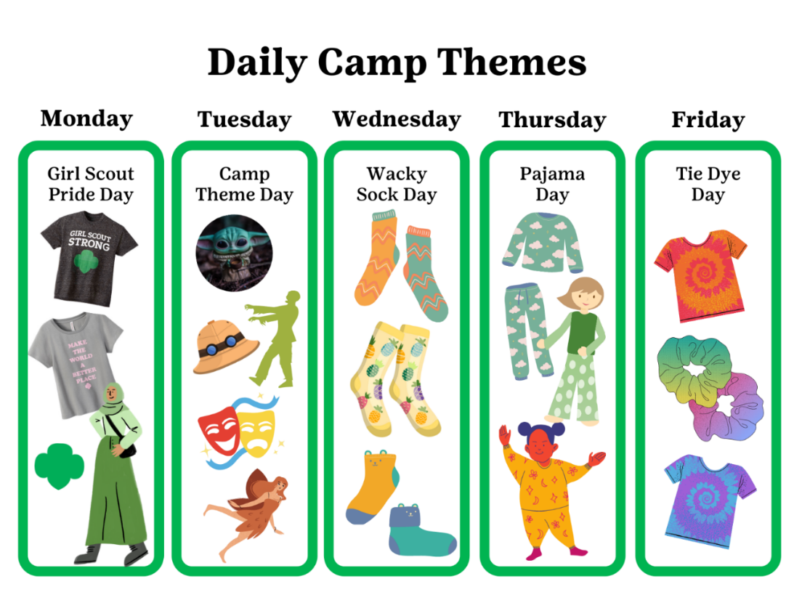

**POOL TIME**

We swim **every day**. Please pack your camper a swimsuit, towel, and sunscreen. Each Monday, a swim test will be conducted. Campers who elect to not take the swim test or do not pass the swim test will wear lifejackets for the duration of the week while swimming. If you own a US Coast Guard approved personal floatation device that your Girl Scout prefers, please send this to camp with them each day.

**TRADING POST**

The Trading Post will be open once a week for campers to shop. We recommend that campers not keep money with them. Money can be placed in an envelope with the Girl Scout’s name and turned in to staff at check-in. These funds will be available for them when they visit the Trading Post. Girl Scouts may also use Cookie Dough earned from participating in the Product Program (cookie sale) – if an adult would like to limit the amount of Cookie Dough their Girl Scout spends at the Trading Post, they should provide a note in writing to a member of the camp staff during check-in. The Hacienda Day Camp is not responsible for money that is kept with the individual camper and not handed in at check-in.

**MOVIE SHOWING**

Every Friday afternoon, campers will gather to view a movie that matches the theme for that week of camp. Movies will be rated either G or PG and will have been pre-screened by camp staff to ensure the content is appropriate. Most movies shown are produced by Disney, Pixar, Dreamworks, Illumination, etc.

**HACIENDA MAP**

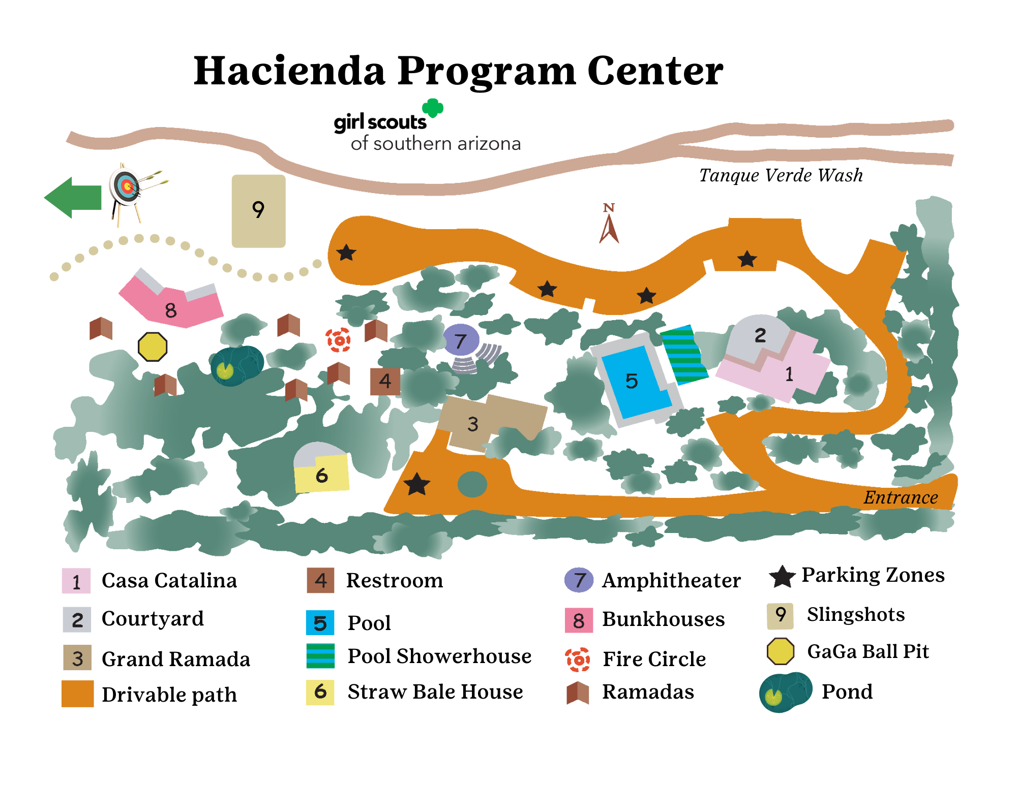

We hope this information will help you prepare your Girl Scout for an exciting time at Day Camp; we look forward to spending the summer together!

Yours in Girl Scouting,

Sequoia (Pixie) Smith

Cass (Sparky) Johnson

Day Camp Directors

Girl Scouts of Southern Arizona

3101 N Sabino Canyon Rd.

Tucson, AZ 85715

HaciendaCamp@girlscoutssoaz.org

(520) 319-3180